Project Design Phase -||
Technology Stack(Architecture & Stack)

Date | 10 AUG 2025
Team ID | PNT2025TMID12444
Project Name | Garage Management System
Maximum Marks

Technical Architecture:

1. Presentation Layer (Frontend)
- Purpose: Interface where users interact with the system (e.g. booking appointments, tracking jobs).
- Technologies: HTML, CSS, JavaScript, frameworks like React or Angular
- Devices Supported: Desktop browsers, tablets, possibly mobile apps

2. Application Layer (Backend)
- Purpose: Core business logic – handles job assignments, billing, customer profiles, etc.
- Technologies: Node.js, Python (Django/Flask), Java (Spring Boot), or .NET
• Responsibilities:
- Processing user requests
- Enforcing business rules
- Managing notifications and workflows

3. Data Layer (Database)
- Purpose: Store and retrieve structured data for vehicles, customers, parts, services, and transactions
Technologies:
- Relational DBMS: PostgreSQL, MySQL, SQL Server
- NoSQL (optional for logs or analytics): MongoDB

4. Integration Layer
- Purpose: Enables communication with third-party tools or services
- Examples:
- SMS/email gateways for reminders
- Payment gateways
- Inventory suppliers
- APIs for vehicle diagnostics (if advanced)

5. Security Layer (Cross-cutting concern)
- Role-based access control (RBAC)
- HTTPS/SSL encryption
- Authentication via OAuth2 or JWT

6. Deployment & Infrastructure
- Deployment Options: Cloud-hosted (e.g. AWS, Azure, GCP) or on-premise
- Containerization: Docker, Kubernetes for scalability
- CI/CD: Jenkins, GitHub Actions for automated builds and testing
- Backup & Recovery Tools

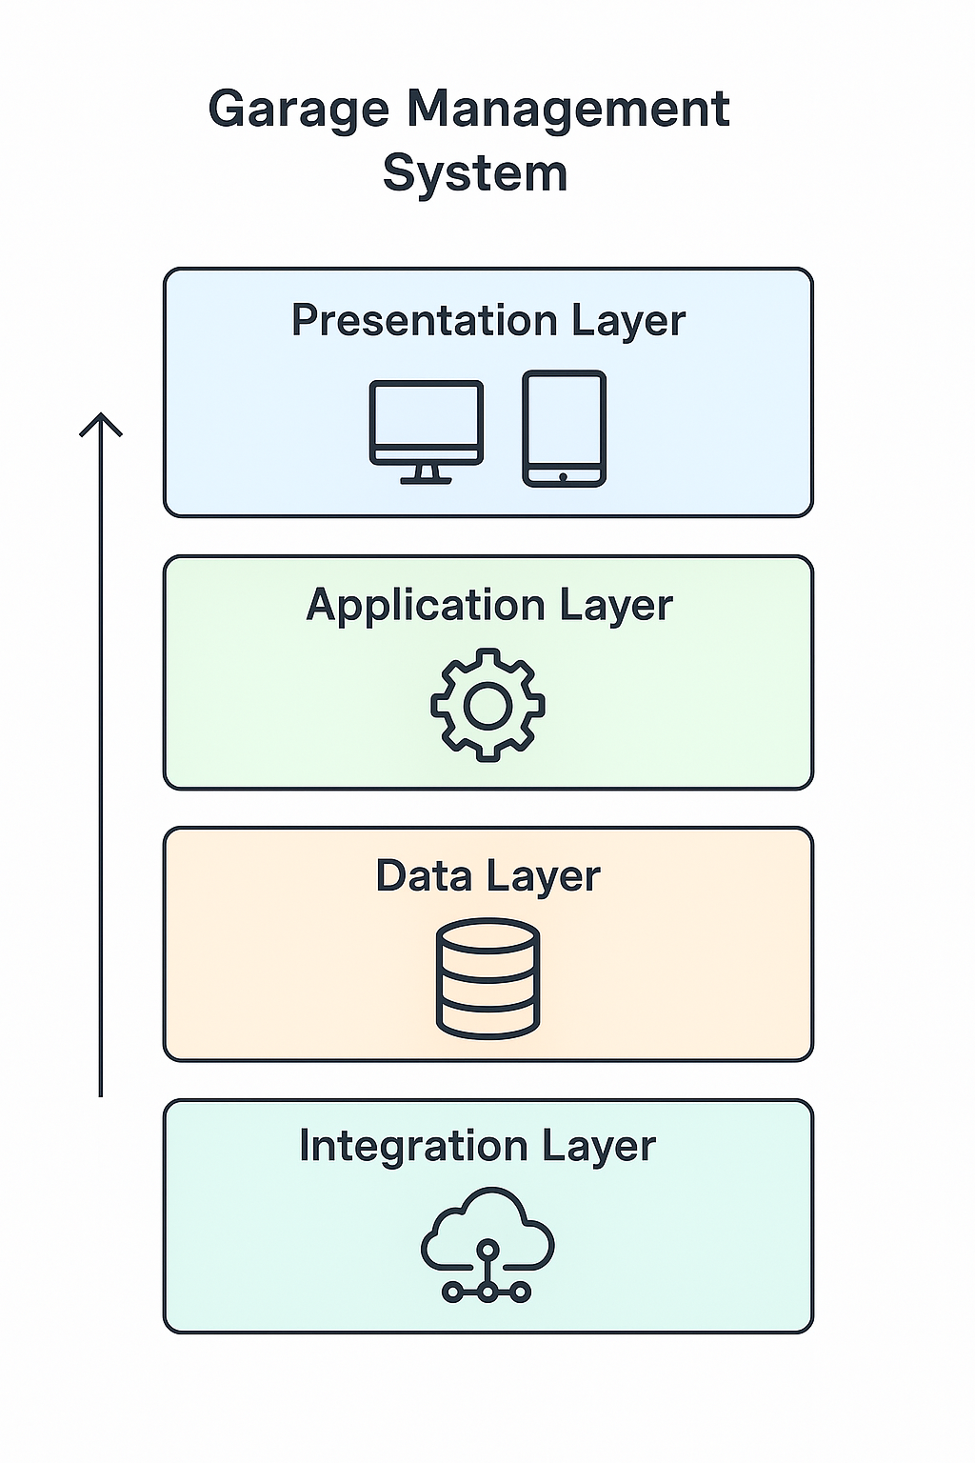

Stack:

Frontend (Client-Side)
Where users interact with the system
- Languages: HTML5, CSS3, JavaScript
- Frameworks: React.js or Angular
- Styling: Tailwind CSS or Bootstrap
- State Management: Redux (if using React)

Backend (Server-Side Logic)
Where all business logic is handled
- Languages: Node.js (JavaScript), Python (Django/Flask), or Java (Spring Boot)
- Frameworks/Platforms: Express (Node.js), Django (Python)
- API Architecture: REST or GraphQL
- Authentication: JWT (JSON Web Tokens) or OAuth2

Database Layer
Stores structured and unstructured data
- Relational DB: PostgreSQL or MySQL
- NoSQL DB (optional): MongoDB (for logs, analytics, flexible data models)
- Caching: Redis (for speeding up access to frequently used data)

Infrastructure & Deployment
Where and how the app runs
- Containerization: Docker
- Orchestration: Kubernetes (for scalability and fault tolerance)
- Cloud Providers: AWS (EC2, RDS, S3), Azure, or Google Cloud
- CI/CD Pipelines: GitHub Actions, GitLab CI, or Jenkins

Security & Monitoring
Protects data and maintains system health
- Security Protocols: HTTPS, TLS, CSRF/XSS protection libraries
- Monitoring Tools: Prometheus, Grafana, or Datadog
- Logging: ELK Stack (Elasticsearch, Logstash, Kibana) or Loki

Optional Enhancements
Adds value, especially in customer experience
- Mobile App: React Native or Flutter for cross-platform apps
- Notification Services: Firebase Cloud Messaging, Twilio (for SMS), or SendGrid (for emails)

